import matplotlib.pyplot as plt

dict1 = {1:2, 3:4, 5:6}

dict2 = {7:8, 9:10, 11:12}

dict3 = {13:14, 15:16, 17:18}

data = (**dict1, dict2, dict3)**

colors = ('r', 'g', 'b')

groups = ('First','Second','Third')

for datum, color, group in zip(data, colors, groups):

plt.scatter(datum.keys(), datum.values(), c=color, label=group)

plt.legend(loc=2)

plt.show()

[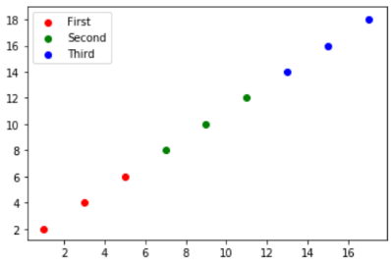](https://i.stack.imgur.com/KPU2l.png)